Combination Sum III
Problem Statement: Determine all possible set of k numbers that can be added together to equal n while meeting the following requirements:
1. There is only use of numerals 1 through 9.
2. A single use is made of each number.
Return list of every feasible combination that is allowed. The combinations can be returned in any order, but the list cannot have the same combination twice.
Examples
Example 1:
Input: k = 3, n = 7
Output: [[1, 2, 4]]
Explanation:
1 + 2 + 4 = 7
There are no other valid combinations.

Example 2:
Input: k = 3, n = 9
Output: [[1, 2, 6],[1, 3, 5],[2, 3, 4]]
Explanation:
1 + 2 + 6 = 9, 1 + 3 + 5 = 9, 2 + 3 + 4 = 9, There are no other valid combinations.
Algorithm
- Use backtracking to explore all possible number combinations that sum up to a target.
- Track the current combination and remaining target as you build solutions incrementally.
- If a valid combination meets both the target sum and required size, store it in the results.
- Prune the path early if the sum goes negative or the combination exceeds the allowed size.
- Explore the search space by trying each number, then undoing the choice to backtrack and try alternatives.
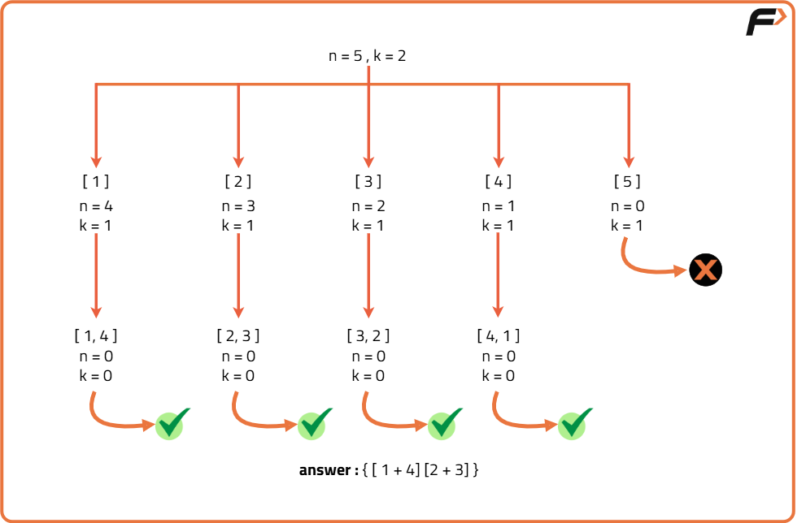
Code
import java.util.ArrayList;
import java.util.List;
class Solution {
private void func(int sum, int last, List<Integer> nums, int k, List<List<Integer>> ans) {
// If the sum is zero and the number of elements is k
if (sum == 0 && nums.size() == k) {
// Add the current combination to the answer
ans.add(new ArrayList<>(nums));
return;
}
// If the sum is less than or equal to zero or the number of elements exceeds k
if (sum <= 0 || nums.size() > k) return;

// Iterate from the last number to 9
for (int i = last; i <= 9; i++) {
// If the current number is less than or equal to the sum
if (i <= sum) {
// Add the number to the current combination
nums.add(i);
// Recursive call with updated sum and next number
func(sum - i, i + 1, nums, k, ans);
// Remove the last number to backtrack
nums.remove(nums.size() - 1);
} else {
// If the number is greater than the sum, break the loop
break;
}
}
}
public List<List<Integer>> combinationSum3(int k, int n) {
List<List<Integer>> ans = new ArrayList<>();
List<Integer> nums = new ArrayList<>();
// Call the recursive function with initial parameters
func(n, 1, nums, k, ans);
return ans;
}
}
Complexity Analysis
Time Complexity: O(2^9 * k), due to the exploration of all subsets of the set {1, 2, ..., 9}..
Space Complexity: O(k), where k is the number of elements in the combination. This is due to the space used by the recursive call stack and the storage of valid combinations.

